**Home Page: Section #1**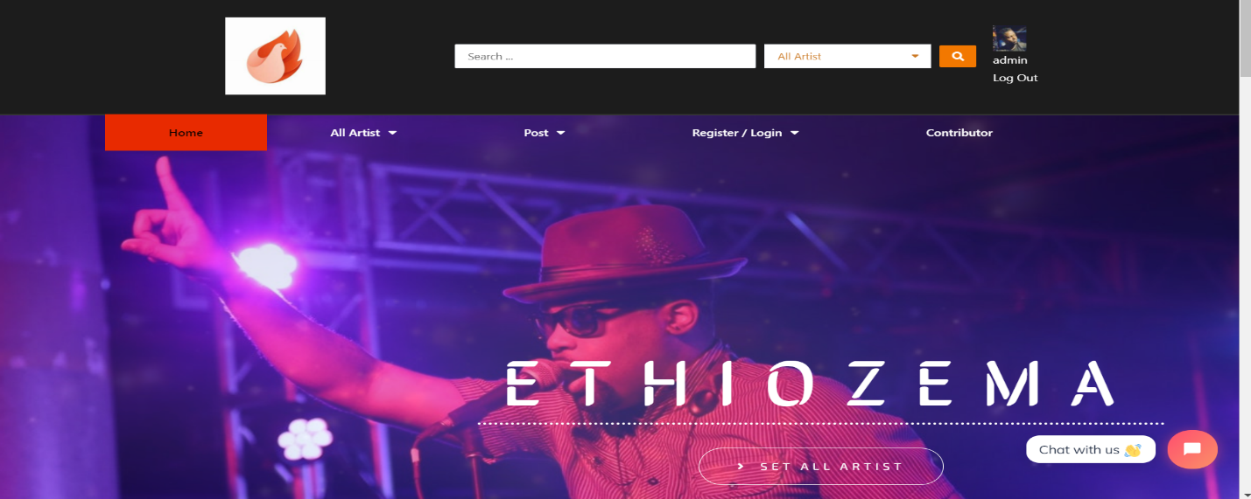



* **The home page is what users see first immediately after logging in. The home page consists of the navigation bar and image links to the most searched artists.**

**All Artists Page: Section #2**



* **This is where users access all the artists that are on the website. The page also makes it possible for users to select and save their favorite songs.**

**Contributor page: Section #3**

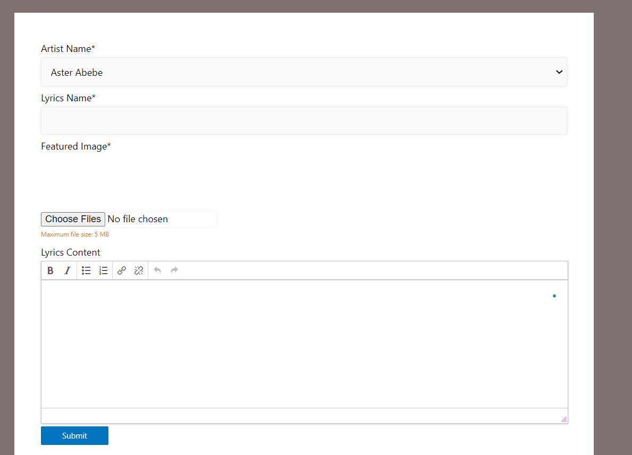

* **This page allows users to contribute a song. Every submission must go through admin approval.**

**Favorite Tracks page: Section # 4**



* **This is where users access their favorite songs.**

**Group’s page: Section #6**

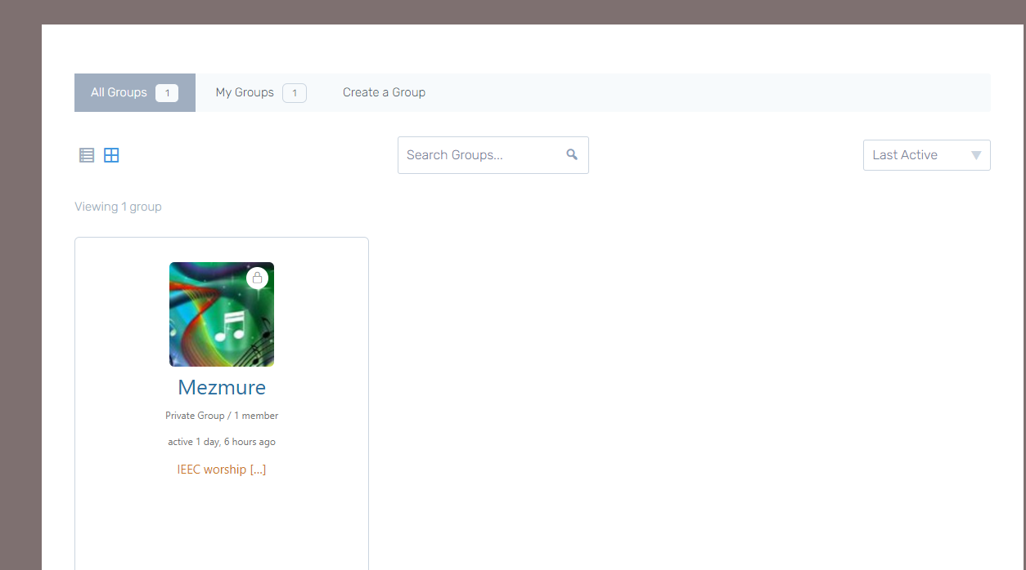

* **This is where users either join or create a group.**

**Members Page: section #7**

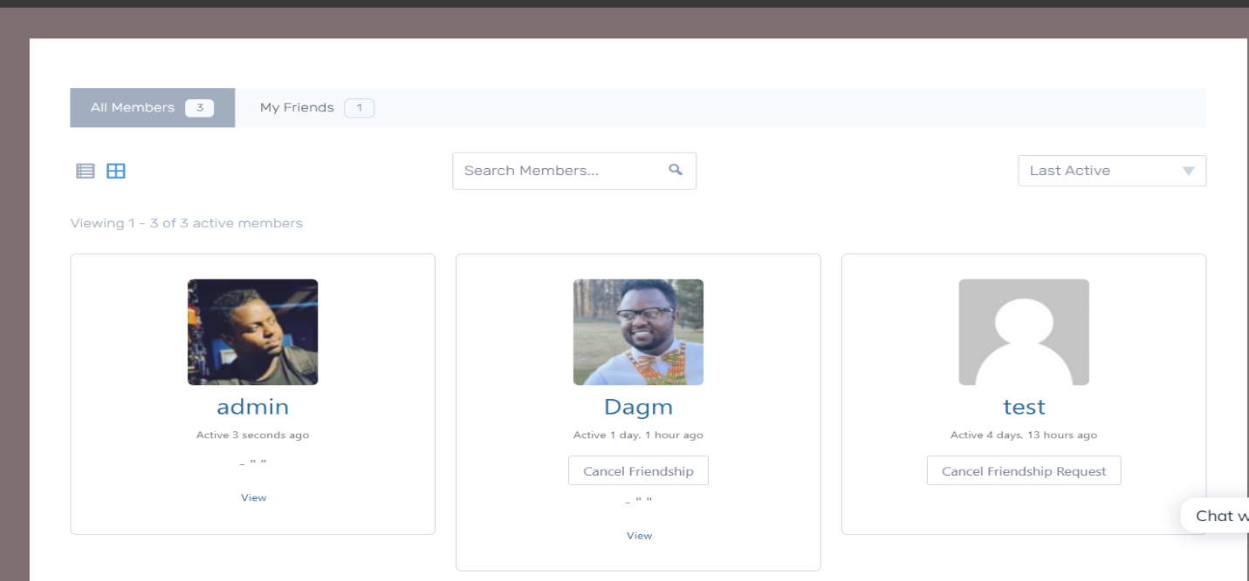

* **This is where users access their profile, and also do a friend request.**

**Users profile page: section #8**

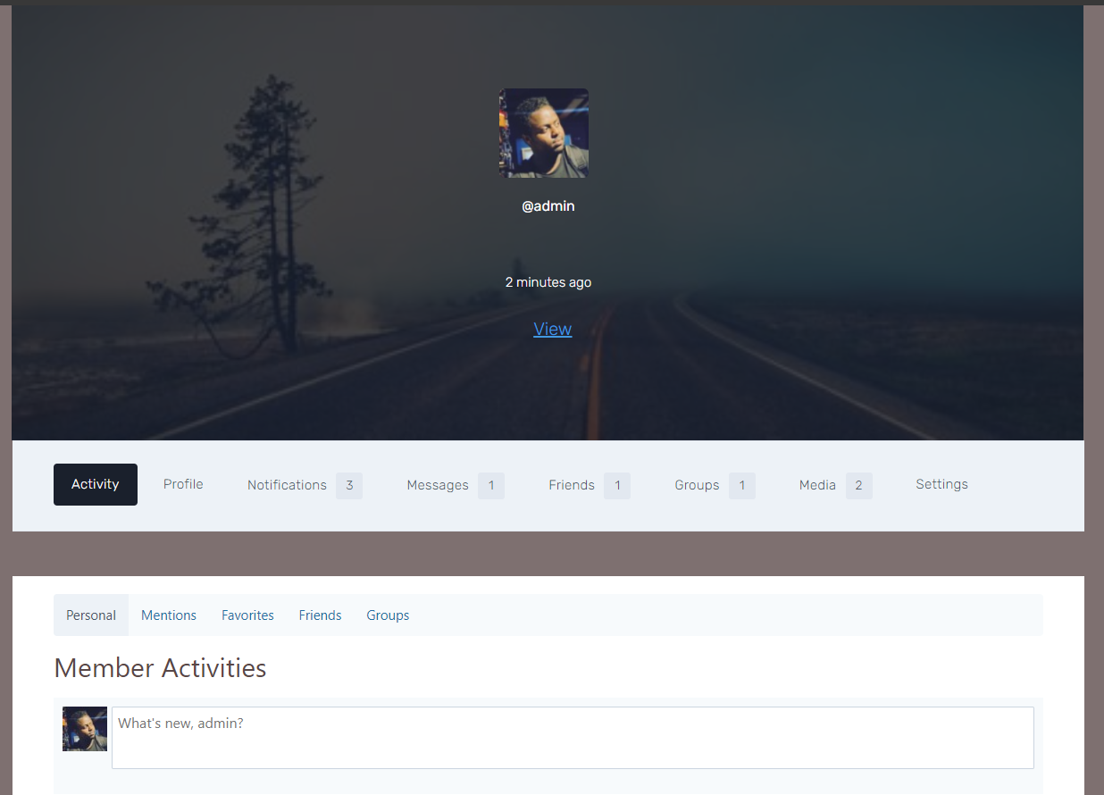

**User Profile page allows users to:**

**● edit their profile, post contents and chat with other members.**

**● send a friend request to other members of the website**

**● create or join a group**

**● get a notification when other members post a content**

**Register/log in page: section #9**

* **Users have the ability to log in or register if that is their first time on the website.**